Police Case Management System

IT214 Database Management System

Group 15
202101262- Krisha Mehta
202101263- Dhruv Limbad
202101465- Keyur Rathva
202101515- Kirtika Basant

ER Diagram

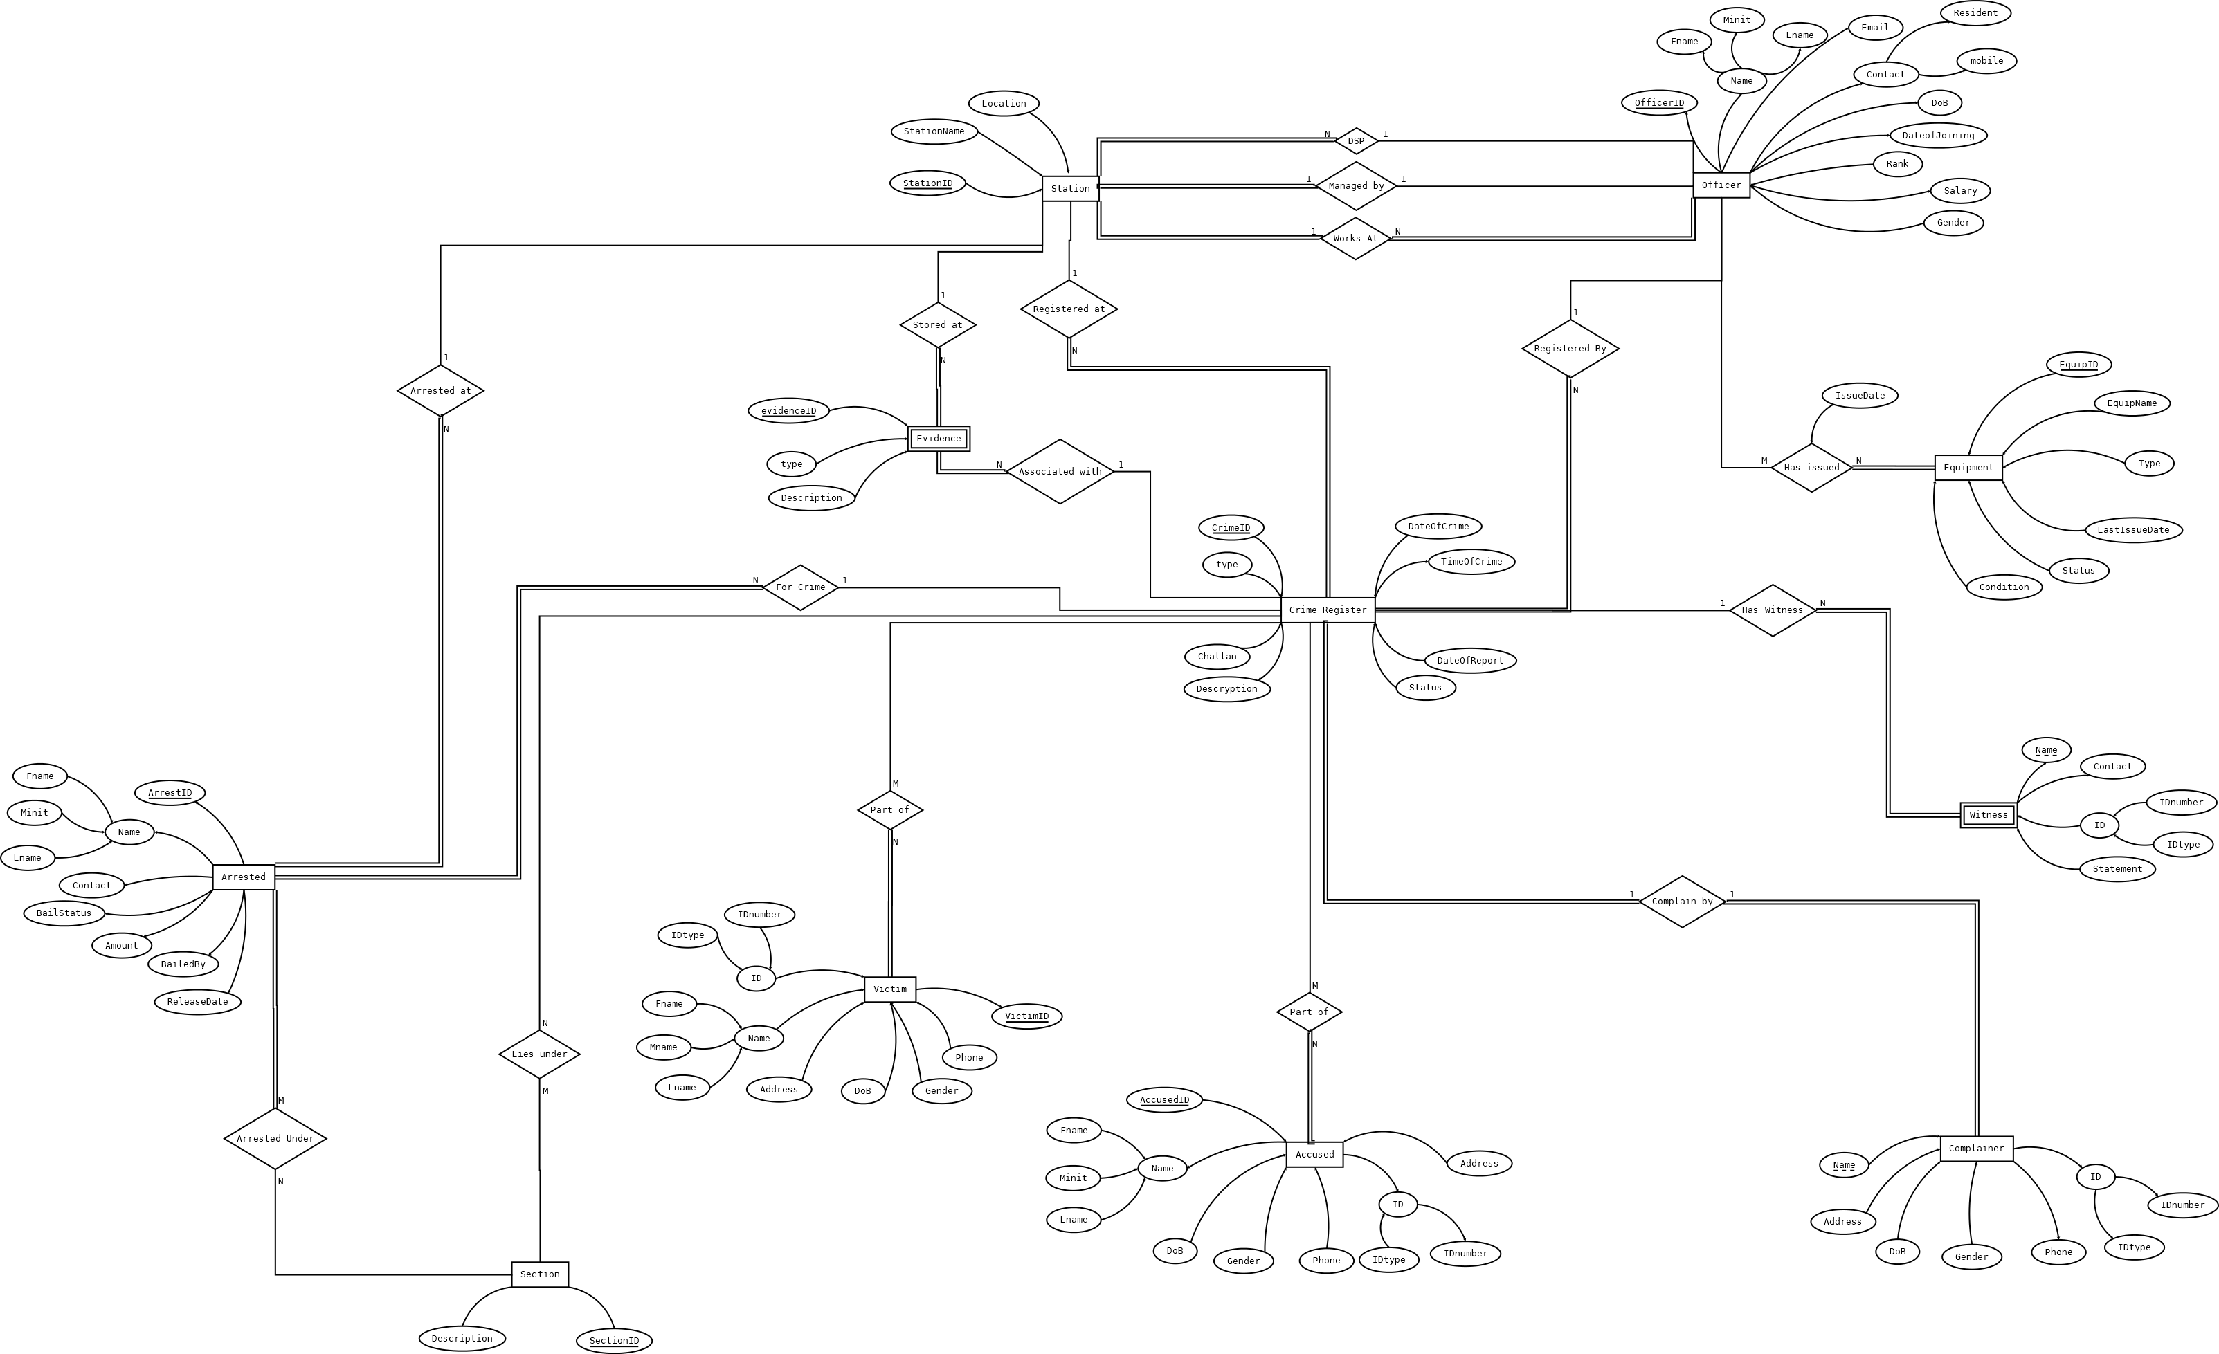
Relational Schema

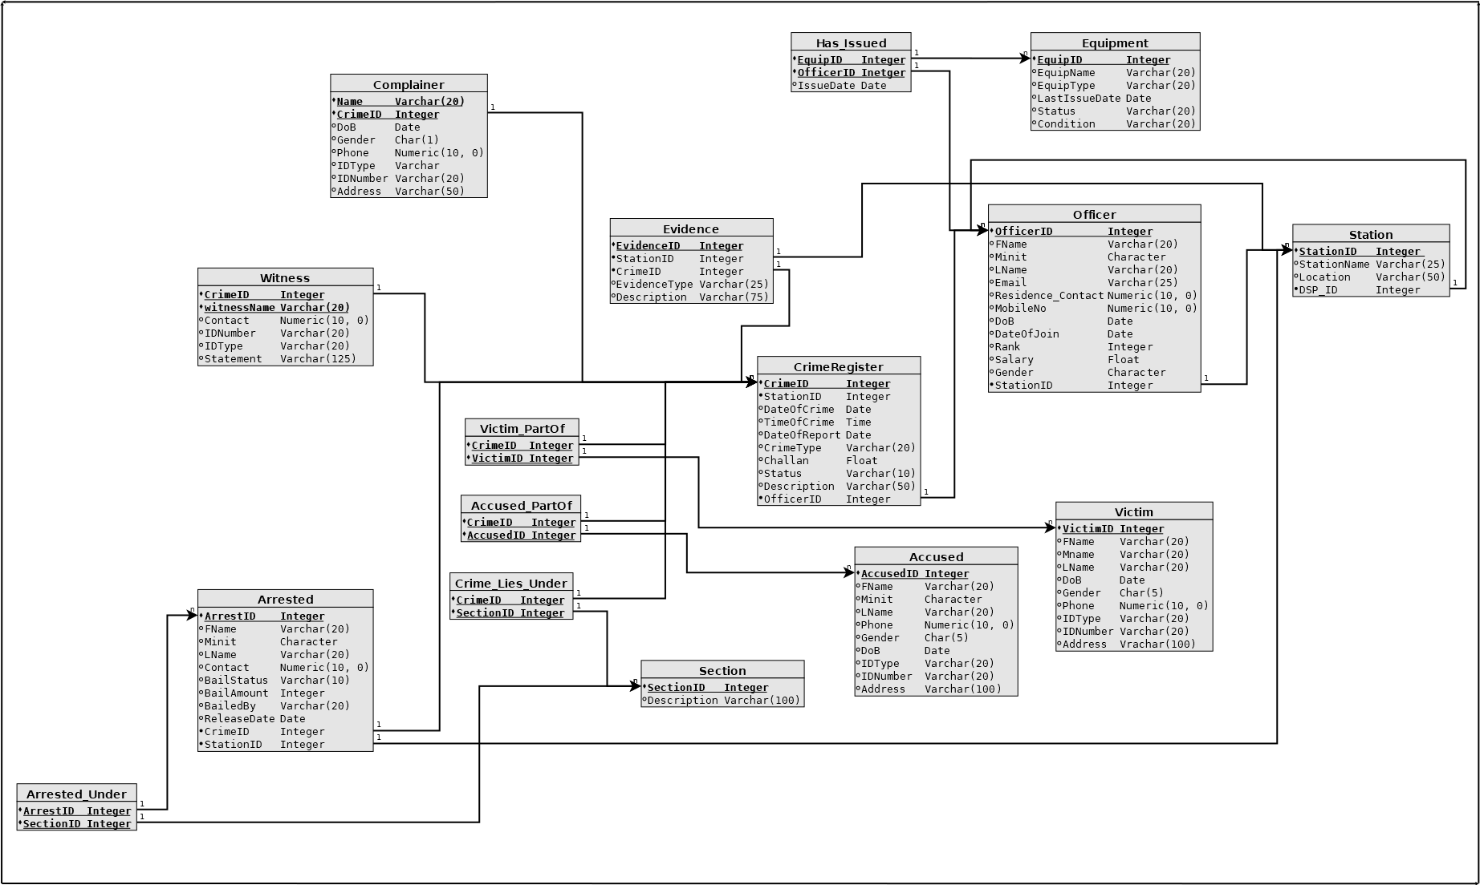

Minimal FD set and Proof that Relations are in BCNF

1. CrimeRegister
Attributes: ( CrimeID, StationID, DateOfCrime, TimeOfCrime, DateOfReport, CrimeType, Challan, Status, Description, OfficerID)

Minimal FD set:
CrimeID -> StationID
CrimeID -> DateOfCrime
CrimeID -> TimeOfCrime
CrimeID -> DateOfReport
CrimeID -> CrimeType
CrimeID -> Challan
CrimeID -> Status
CrimeID -> Description
CrimeID -> OfficerID

Closure of CrimeID:
CrimeID+ = {StationID, DateOfCrime, TimeOfCrime, DateOfReport, CrimeType, Challan, Status, Description, OfficerID}

Here Every element is functionally depended on CrimeID directly, therefore key is CrimeID.

Hence, Relation is in BCNF.

2. OfficerID
Attributes: (OfficerID, Fname, Minit, Lname, Email, Res_Contact, MobileNo, DoB, DateofJoin, Rank, Salary, Gender, StationID)

Minimal FD set:
OfficerID -> Fname
OfficerID -> Minit
OfficerID -> Lname
OfficerID -> Email
OfficerID -> Res_Contact
OfficerID -> MobileNo
OfficerID -> DoB
OfficerID -> DateofJoin
OfficerID -> Rank
OfficerID -> Salary
OfficerID -> Gender
OfficerID -> StationID

Closure of OfficerID:
OfficerID+ = {Fname, Minit, Lname, Email, Res_Contact, MobileNo, DoB, DateofJoin, Rank, Salary, Gender, StationID}

Here, every attribute of Officer is functionally dependent on OfficerID, therefore key is OfficerID.

Hence, Relation is in BCNF.

3. Station
Attributes: ( StationID, StationName, Location, DSP_ID)

Minimal FD set:
StationID -> StationName
StationID -> Location
StationID -> DSP_ID

Closure of StationID:
StationID+ = {StationName, Location, DSP_ID}

Here, every attribute is functionally dependent on StationID, therefore StationID is the key.

Hence, Relation is in BCNF.

4. Complainer
Attributes: (Name, Address, DoB, Gender, Phone, IDType, IDNumber, CrimeID)

Minimal FD set:
{Name, CrimeID} -> Minit
{Name, CrimeID} -> Lname
{Name, CrimeID} -> Address
{Name, CrimeID} -> DoB
{Name, CrimeID} -> Gender
{Name, CrimeID} -> Phone
{Name, CrimeID} -> IDType
{Name, CrimeID} -> IDnumber

Closure of {Fname, CrimeID}:
{Name, CrimeID}+ = {Name, Minit, Lname, Address, DoB, Gender, Phone, IDType, IDNumber, CrimeID}

Here, Complainer is a weak entity. And its key is {Name, CrimeID}. And every attribute of relation is directly depended on key.

Therefore, Relation is in BCNF.

5. Accused
Attributes: (AccusedID, Fname, Minit, Lname, Phone, Gender, DoB, IDType, IDNumber, Address)

Minimal FD set:
AccusedID -> Fname
AccusedID -> Minit
AccusedID -> Lname
AccusedID -> Phone
AccusedID -> DoB
AccusedID -> Gender
AccusedID -> IDType
AccusedID -> IDNumber
AccusedID -> Address

Closure of AccusedID:
AccusedID+ = {Fname, Minit, Lname, Phone, Gender, DoB, IDType, IDNumber, Address}

Here, every attribute of Accused is functionally dependent on AccusedID, therefore key is AccusedID.

Hence, Relation is in BCNF.

6. Victim
Attributes: (VictimID, Fname, Minit, Lname, Phone, Gender, DoB, IDType, IDNumber, Address)

Minimal FDs:
VictimID-> Fname
VictimID-> Minit
VictimID-> Lname
VictimID-> Phone
VictimID-> DoB
VictimID-> Gender
VictimID-> IDType
VictimID-> IDNumber
VictimID-> Address

Closure of VictimID:
VictimID+ = {Fname, Minit, Lname, Phone, Gender, DoB, IDType, IDNumber, Address}

Here, every attribute of Victim is functionally dependent on VictimID, therefore key is VictimID.

Hence, Relation is in BCNF.

7. Arrested
Attributes: (ArrestID, Fname, Minit, Lname, Contact, BailStatus, Amount, BailBy, ReleaseDate, StationID, CrimeID)

Minimal FD set:
ArrestID -> Fname
ArrestID -> Minit
ArrestID -> Lname
ArrestID -> Contact
ArrestID -> BailStatus
ArrestID -> Amount
ArrestID -> BailBy
ArrestID -> ReleaseDate
ArrestID -> StationID
ArrestID -> CrimeID

Closure of ArrestID:
ArrestID+ = {Fname, Minit, Lname, Contact, BailStatus, Amount, BailBy, ReleaseDate, StationID, CrimeID}

Here, every attribute of Arrested is functionally dependent on ArrestID, therefore key is ArrestID.

Hence, Relation is in BCNF.

8. Equipment
Attributes: (EquipID, EquipName, EquipType, LastIssueDate, Status, Condition)

Minimal FD set:
EquipID -> EquipName
EquipID -> EquipType
EquipID -> LastIssueDate
EquipID -> Status
EquipID -> Condition

Closure of EquipID:
EquipID+ = { EquipName, EquipType, LastIssueDate, Status, Condition}

Here, every attribute of Equipment is functionally dependent on EquipID, therefore key is EquipID.

Hence, Relation is in BCNF.

9. Evidence
Attributes: (EvidenceID, CrimeID, StationID, EvidenceType, Description)

Minimal FDs:
EvidenceID -> CrimeID
EvidenceID -> StationID
EvidenceID -> EvidenceType
EvidenceID -> Description

Closure of EvidenceID:
EvidenceID+ = {CrimeID, StationID, EvidenceType, Description}

Here, every attribute of Evidence is functionally dependent on EvidenceID, therefore key is EvidenceID.

Hence, Relation is in BCNF.

10. Witness
Attributes: (CrimeID, witnessName, Contact, IDType, IDNumber, Statement)

Minimal FD set:
{witnessName, CrimeID} -> contact
{witnessName, CrimeID} -> IDType
{witnessName, CrimeID} -> IDNumber
{witnessName, CrimeID} -> Statement

Closure or witnessName:
witnessName+ = {witnessName}

Closure of {witnessName, CrimeID}:
{witnessName, CrimeID}+ = { Contact, IDType, IDNumber, Statement}

Here, every attribute of Witness is functionally dependent on {witnessName, CrimeID}, therefore key is {witnessName, CrimeID}.

Hence, Relation is in BCNF.

11. Section
Attributes: (SectionID, Description)

Minimal FD set:
SectionID -> Description

Here, every attribute of Section is functionally dependent on SectionID, therefore key is SectionID.

Also, any relation with only two attributes is always in BCNF, Therefore this relation is also in BCNF.

12. Arrested_Under
Attributes: (ArrestID, SectionID)

Here both combined are the primary key and include no other attribute.
Therefore key is {ArrestID, SectionID}

Also, any relation with only two attributes is always in BCNF, Therefore this relation is also in BCNF.

13. Crime_Lies_Under
Attributes: (CrimeID, SectionID)

Here both combined are the primary key and include no other attribute.
Therefore key is {CrimeID, SectionID}

Also, any relation with only two attributes is always in BCNF, Therefore this relation is also in BCNF.

14. Accused_Partof
Attributes: (AccusedID, CrimeID)

Here both combined are the primary key and include no other attribute.
Therefore key is {AccusedID, CrimeID}

Also, any relation with only two attributes is always in BCNF, Therefore this relation is also in BCNF.

15. Victim_Partof
Attributes: (VictimID, CrimeID)

Here both combined are the primary key and include no other attribute.
Therefore key is {VictimID, CrimeID}

Also, any relation with only two attributes is always in BCNF, Therefore this relation is also in BCNF.

16. Has_issued
Attributes: (officerID, EquipID, issueDate)

Minimal FD set:
{officerID, EquipID} -> issueDate

Here, every attribute of Has_issued is functionally dependent on {officerID, EquipID, therefore key is {officerID, EquipID.
Hence, Relation is in BCNF.

